Chapter 6, Problem 85.

A square-wave generator produces the voltage waveform shown in Fig. 6.94(a). What kind of a circuit component is needed to convert the voltage waveform to the triangular current waveform shown in Fig. 6.94(b)? Calculate the value of the component, assuming that it is initially uncharged.

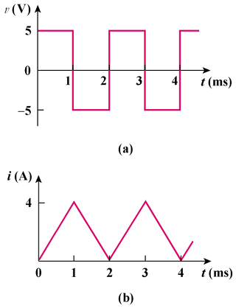

Figure 6.94
For Prob. 6.85.

